**Is that Doc!?**

**Concept Name**

* Is that Doc!?

**Genre**

* Run and gun
* Platformer

**Core Mechanic**

* Shoot and kill all enemy

**Progressive Mechanics**

* Boss fight
* Score Challenging

**Goal Mechanic**

* Get High score

**Play Mechanics**

* Mouse to aim and click to shoot
* W A S D to control the character
* Space to jump
* Smooth Run and guns

**User Experience**

* Beginning of the game player will get the tutorial by play in first state

After player know how to play in each level will increase difficulty and player will fight with boss at the end of the game

**Theme**

* Present world
* Medical

**Story**

* Great Doctor got metal problem during Covid-19 Breakdown and His mind have blown, after that he can see the virus by his eyes then, he grab the weapons and run for kill all of the virus.

**Ref.**

*My friend Predo*

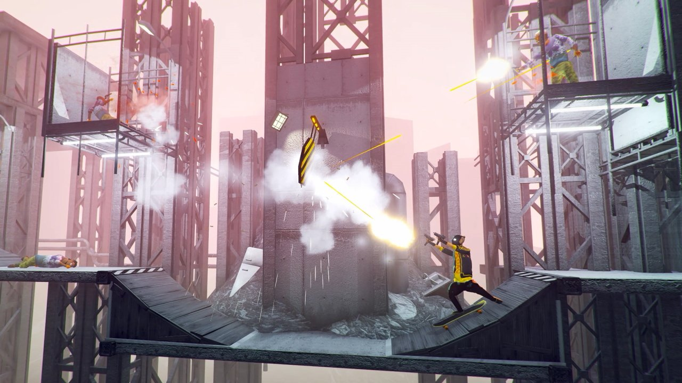

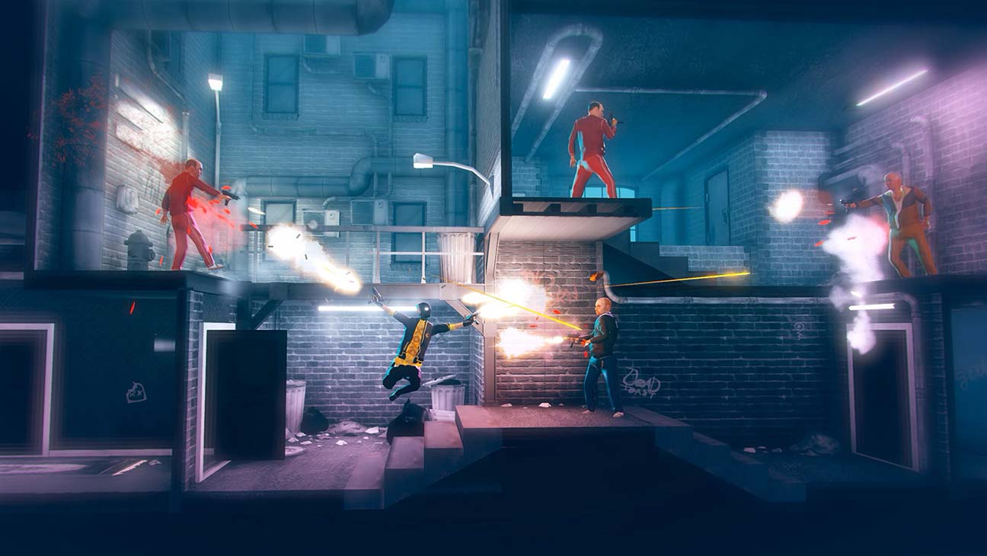

*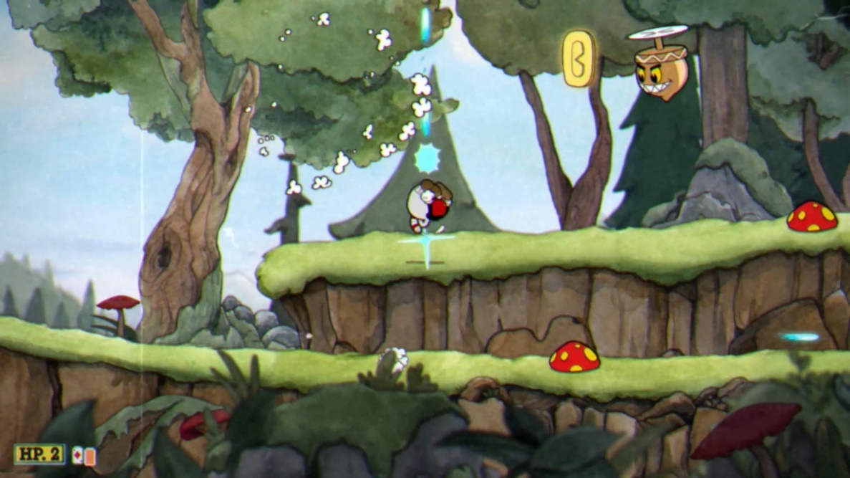Cuphead*

*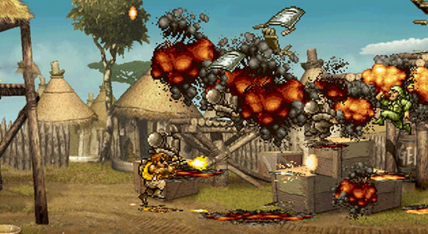Metal Slug*